Beyond Bibliometrics: Large Language Models (LLMs) and Human Expertise Can Advance Novelty Assessment

S.1. Overview and Construct.
The winning indicator, LENS (LLM-Evaluated Novelty & Significance), is at its core a method that uses multiple calls to large off-the-shelf language models (LLMs) in order to evaluate the novelty of a research article in the context of its field(s) at the time of publication. The developers of LENS define novelty as scientific significance and field-shaping potential, that is, how valuable is the contribution to advancing scientific knowledge. The construct therefore combines raw newness with relevance and scientific rigor, taking a value-oriented interpretation that leans toward the standard definition of creativity (Runco and Jaeger 2012). This interpretation was chosen because it rules out ideas that are different but useless or poorly executed, which would not match the inherently positive connotation of novelty. Beyond this definition, the design of the method rests on the following hypotheses:
- To assess novelty according to a definition that goes beyond dissimilarity (e.g., Shibayama et al. 2021) and recombination (e.g., Uzzi et al. 2013), it is necessary to reason about the content of a publication or a description of it. Metadata can only provide a proxy signal.
- Novelty is relative to the state of the field(s) at publication time. Therefore, to have comparable novelty scores, the contributions must be assessed as of the publication date, which yields a “birthday-score”. Scoring novelty in retrospect must make sure the method is not aware of the reception of the article and the field trajectory post-publication (to avoid Matthew effects; viz. Merton, 1968), and not to introduce hindsight bias (Fischhoff 1975).
- To assess novelty, both broad world knowledge and specific, contextual knowledge are required. References cited provide some information, but LLMs complement them by drawing on extensive training data, including scholarly literature and scientific trend discussions, to more fully reconstruct a field’s state over time.
- Novelty is subjective, and experts often disagree in their assessments (Boudreau et al. 2016, Pier et al. 2018). Because of their broad training, LLMs can adapt to the perspectives of different research fields (Liang et al. 2024). Furthermore, the developer assumed, giving their training objective they tend toward a weighted consensus judgment on qualitative criteria, making them especially well suited to perform against a diverse expert panel.

S.2. Pipeline.
LENS runs in four stages: (1) retrieving the inputs, (2) preparing the inputs for the assessment stage with a small LLM, (3) assessing novelty and its uncertainty with a large LLM, and (4) postprocessing the assessment output (see Figure S.1).
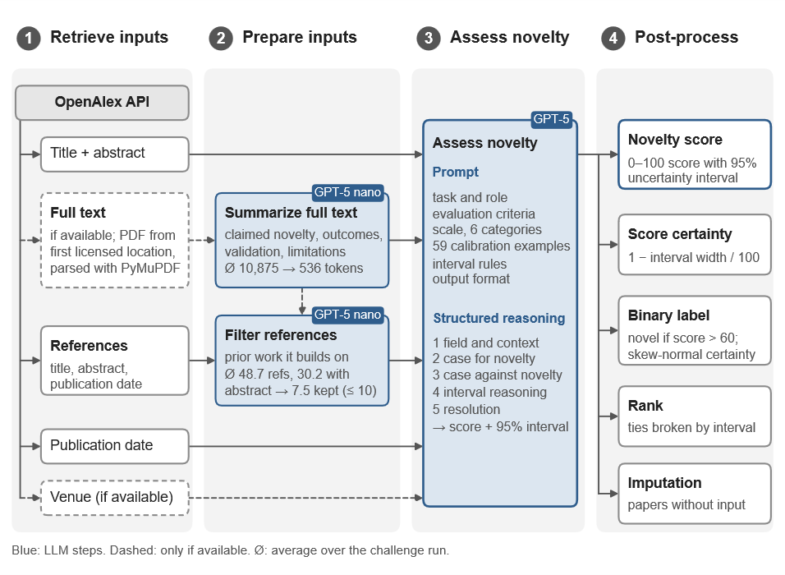
Figure S.1. Pipeline of LENS from Input Retrieval to Postprocessing.
In the first stage, the metadata of the Challenge papers (abstract, references with title and abstract, and download locations) are retrieved from the OpenAlex API (Priem et al. 2022), and the full texts are downloaded as PDF files from the first available location with appropriate licensing. The PDFs were parsed into a machine-readable representation using PyMuPDF.
In the second stage, a small LLM (see Table S.1) summarizes the full text, if one was retrieved, focusing on the claimed novelty, outcomes, and importance as well as on the validation approach, key insights and stated limitations. This step reduces the input size, and therefore the cost of the assessment stage, and standardizes the content in order to reduce the influence of writing style and verbosity of the inputs on the result (Zheng et al. 2023, Dubois et al. 2024). The paper’s reference list is then filtered by a small LLM to the most important prior works that laid the foundation for the work under evaluation, i.e., direct baselines, methodological foundation, problem definitions and work which directly conflict with the articles theses. References whose abstract could not be retrieved from OpenAlex were excluded automatically.
In the third stage, the novelty assessment is performed. The prepared inputs are given to a large reasoning model with instructions on how to perform the assessment. The model is instructed to weigh arguments for and against novelty, to place the paper on a 0–100 scale, and to give lower and upper bounds representing a 95% uncertainty interval. The main prompt, its inputs, and its outputs are described in Section S.3. In the last stage, the outputs are post-processed to fit the Challenge format (see Section S.4).
Table S.1. Models and Inputs per Pipeline Step
Step | Model | Snapshot | Reasoning effort | Inputs (excluding prompt)
Summarize content | GPT-5 nano | gpt-5-nano-2025-08-07 | medium | full text, title, abstract
Filter references | GPT-5 nano | gpt-5-nano-2025-08-07 | medium | title, abstract, full-text summary (if available), references with an available abstract (title, abstract, publication date)
Assess novelty | GPT-5 | gpt-5-2025-08-07 | medium | title, abstract, venue, full-text summary, filtered references, publication date

LENS uses GPT-5, OpenAI’s latest proprietary reasoning model family available at the time of development: GPT-5 nano for preprocessing tasks (knowledge cutoff May 31, 2024; OpenAI 2025b) and the full GPT-5 model for the more complex novelty assessment stage (knowledge cutoff September 30, 2024; OpenAI 2025a); see also OpenAI (2025c).

S.2.1. Inputs and coverage
For 58.2% of the roughly 100,000 Challenge papers, both abstract and full text were available; 40.3% were scored from the abstract alone; 1.2% had only a full text without a separate abstract; and for 0.2% neither could be retrieved (Table S.2). The full-text-only papers most likely contain their abstract within the full text, but it was not extracted separately in the Challenge run.
Table S.2. Input Availability in the Challenge Run (≈100,000 papers)
Input condition | Share | Handling
Abstract + Full Text | 58.2% | standard pipeline
Abstract only | 40.3% | summary step skipped; reference filter uses title and abstract
Full text only | 1.2% | standard pipeline without abstract
Neither | 0.2% (210 papers) | no LLM score; imputed in post-processing (S.4)

S.2.2. Run statistics (Challenge run)
On average, the summary stage reduced the full text from 10,875 to about 536 tokens, a roughly 20-fold reduction. The Challenge articles had on average 48.7 references, of which 30.2 (62%) had an abstract available in OpenAlex. The reference filter (second stage, see above) then reduced these to 7.47 references on average.
Between February 8 and 16, 2026, the main Challenge runs were executed using the OpenAI Batch API, which halves the token price for every model. Running all requests for the Challenge cost US$1,567, of which US$1,451 (93%) was spent on the final novelty-scoring prompt. This amounts to an average of about 1.6 U.S. cents per article, excluding taxes. These costs could likely be reduced as smaller models continue to improve in capability.

S.3. Prompt Design and Calibration Examples.
The core of LENS is the novelty assessment prompt, which has seven sections. It begins with (1) a general description of the task and a role assignment for the LLM, followed by (2) a detailed description of the evaluation criteria, which outlines various dimensions of novelty focusing on adapting the criteria to the field and article type and on the contribution’s added value. Next comes (3) the novelty scale from 0 to 100, divided into six categories ranging from “Negligible” through “Solid but Incremental” to “Paradigm-Shifting – Historic”, followed by (4) a list of 59 calibration examples. Finally, there are (5) instructions for assessing the confidence of the score, (6) instructions on the output format, and (7) the input information of the respective article.
The LLM is called with a structured output format that forces it to follow a specified chain of argument: a description of the field and its context at the time of publication; a case for and a case against the paper’s novelty to follow debiasing strategy of considering the opposite (Lord et al. 1984); a justification for the interval based on the remaining uncertainties; and a resolution of these arguments. The output end with the point estimate and the lower and upper bounds of a 95% uncertainty interval (Table S.3). This sequence makes the model generate all the reasoning elements needed for a well-founded verdict before it scores, in case they are not already part of its hidden reasoning tokens. Such explicit intermediate reasoning is known to improve LLM performance (Wei et al. 2022).
Table S.3. Output fields of the assessment prompt
Field | Content
field_and_context | state of the field and its bottleneck at publication
novelty_case | strongest case for novelty
skeptical_counter | strongest case against novelty
interval_reasoning | sources of uncertainty
resolution | weighed verdict
score, lower, upper | point estimate and interval bounds (0.0–100.0), one decimal place

The 59 calibration examples were hand-picked by the LENS developers based on their judgment. They span the whole novelty range, from 1.0 = “Classroom exercises (e.g., implementing k-means from scratch on Iris or measuring G with a pendulum)” to 100.0 = “General Relativity (Einstein)”, and cover named landmark works as well as generic archetypes from different fields, with a focus on highly novel works (>80). There is no overlap between the calibration set and the expert-rated dataset. The calibration examples primary purpose is besides steering the results by anchoring the scale (Brown et al. 2020), to increase consistency between runs, and to make independent LLM inferences comparable. Figure S.2 shows how the anchors are distributed across the scale and the OpenAlex domains. Of the 59 anchors, 32 score 80 or higher, while only 8 fall between 40 and 59, the range that holds most LENS scores. Further work will investigate how the calibration examples influence the scores and how they should be selected (Section S.12).
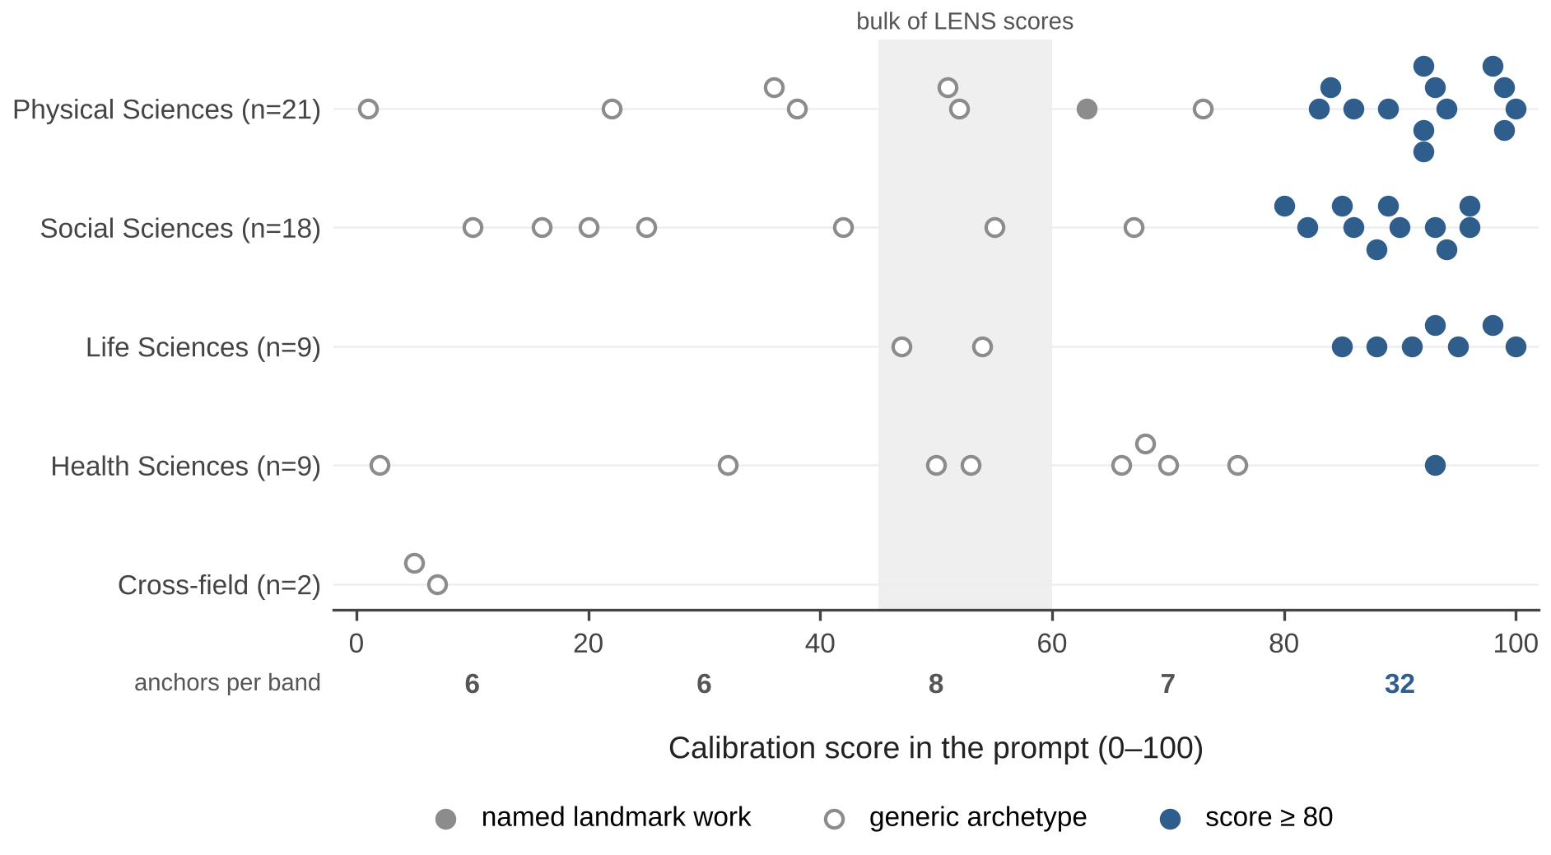
Figure S.2. Calibration Examples in the Evaluation Prompt by Score and OpenAlex dDomain.
Notes. The shaded band marks the range that holds most LENS scores (45–60). Numbers below the axis give the count of anchors per 20-point band.

S.4. Postprocessing
Besides the novelty score, the Challenge required four additional outputs: (1) a novelty certainty instead of an interval, (2) a ranking, and (3) a binary novelty judgement with (4) its own certainty. The following steps were applied to the assessment outputs:
- Imputation: For the 210 papers for which neither abstract nor full text could be retrieved, and for 8 papers that could not be submitted to OpenAI because they deal with sensitive topics (biochemical weapons or gain-of-function research), the novelty score and certainty were set to the mean values of all other articles.
- Score certainty: Computed as a heuristic width measure from the self-proclaimed 95% uncertainty interval that the model reports in the assessment stage (see Section S.3), certainty = 1 − (predicted upper bound− predicted lower bound) / 100, where the bounds are the interval limits on the 0-100 scale. A narrow interval therefore gets a certainty close to 1.
- Binary label: Papers scoring above a selected threshold of 60 were labelled novel, which yields 11,233 (11.2%) novel articles. The LENS developers chose 60 as it is the transition point from standard solid work to highly novel work on the LENS scale, assuming that when experts are asked whether a contribution is novel, they think of novel as highly, above-average novel.
- Binary certainty: A skew-normal distribution (Azzalini 1985) is fitted per paper to the point estimate (treated as the median) and the interval bounds using the Nelder–Mead method (Nelder and Mead 1965). Before fitting, the bounds are treated as a 90% rather than a 95% interval, which deliberately widens the implied uncertainty to account for noisy inputs. The certainty is the probability mass on the predicted side of the threshold. As this was an initial implementation, future work should calibrate these parameters systematically and in consultation with stakeholders (especially, prospective users).
- Ranking: Papers are ranked by their point estimates. Since there are only 1,001 possible values given a precision of one decimal point (0.0 to 100.0 in steps of 0.1), ties are frequent (see Section S.6) and are broken by the expected value of the skew-normal distribution, then by the lower bound, and then by the upper bound. Future research will test how sensitive the ranking is to these rules.

S.5. Method Development and Data Access.
LENS was developed and submitted without any access to the expert ratings, so its Challenge results are out-of-sample. The architecture described in Section S.2 was developed following the principles set out in Section S.1. The prompts were manually optimized on 22 papers scored by members of the LENS developers’ institute in their own fields of expertise, none of which were included in the expert dataset. The prompts were iteratively improved by manually reviewing the reasoning of the model as well as the rankings of the papers. At submission (February 2026), the absolute LENS scores still differed considerably from the scores of these example papers, mirroring the Challenge results (revealed with the Winner decision, in April 2026). The LENS developers never had access to the expert evaluations of the Challenge dataset; the 1000-paper sample provided in the Research Artifact was released to LENS developers only in October 2026). Development relied primarily on papers familiar to LENS developers, introducing a potential field bias toward energy-science or natural language processing. Whether this leads to over- or underestimation of novelty in other fields remains an open question; future work will address it with sensitivity analyses

S.6. Score Output.
Across the roughly 100,000 publications, of which 99,762 could be scored (Table S.4), LENS produces a unimodal, roughly bell-shaped score distribution centered in the category “Solid but incremental” (40–60), which holds 77.5% of all papers (Figure S.3). At a finer resolution, however, the distribution is strongly fragmented. LENS returns a novelty score with one decimal place, resulting in 1,001 possible values. However, only 613 scores are observed, and the 25 most frequent values account for 36.6% of all papers. The most frequent value, 52.7, was assigned 2,695 times. The decimal digits are far from uniform (Figure S.3, inset): the decimal digits 7 and 8 make up 44% of all scores, whereas 0 and 5 almost never occur (which is opposite to human behavioural patterns, who tend to round to 0 and 5). The observed distribution most likely occurs as a LLM-model artefact resulting from the instruction to rate the article “precisely” on a continuous scale, and the model appears to avoid round decimals to signal such precision. Therefore, given this artifact and the run-to-run standard deviation of about 2 points (Section S.9), LENS scores should be compared at a resolution of a few points, not at the first decimal. But the same can be said even to an higher extend for human experts with their average standard deviation of 21.59 between ratings on individual publications, who also tend to certain values and do not use the full scale as can be seen in the expert rating width in Figure S.5.
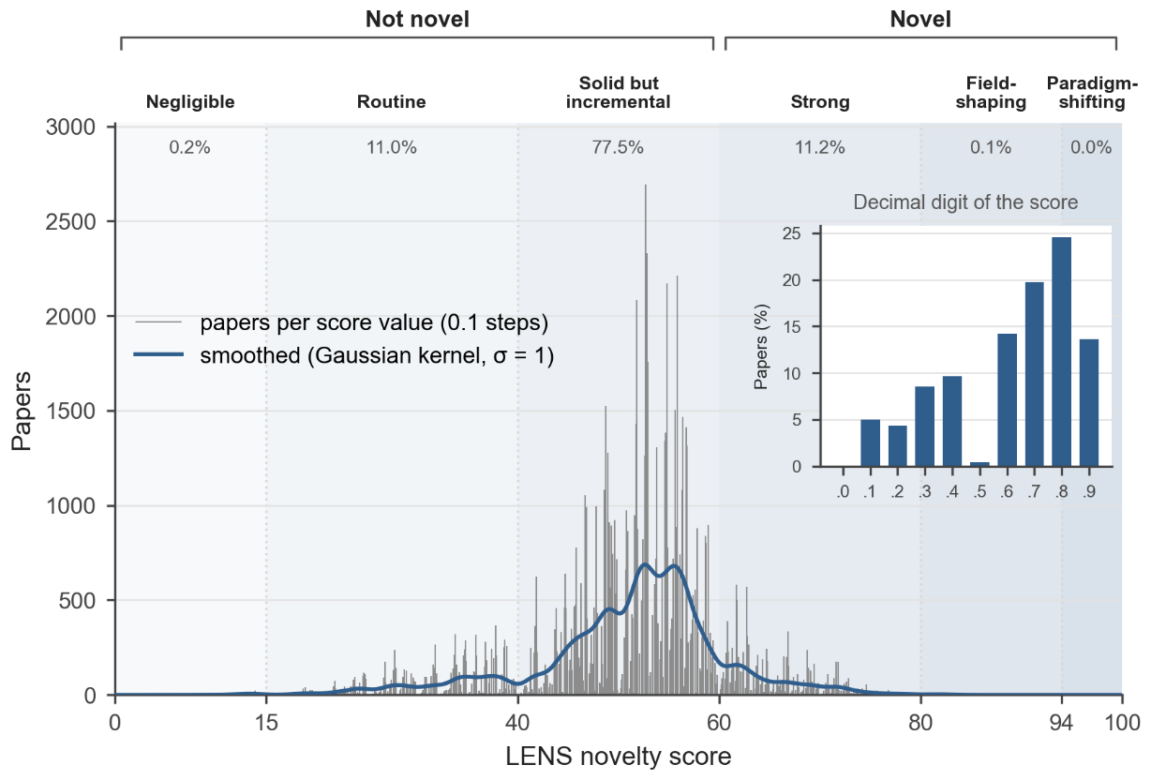
Figure S.3. Distribution of LENS Novelty Scores on the Challenge Data Set
Notes. Thin bars show the number of papers per 0.1-point bin, and the curve is smoothed with a Gaussian kernel (σ = 1). The share of papers in each category of the LENS scale is shown above the plot. The inset shows the share of each decimal digit.

Besides the overall scores, scores also differ slightly by input condition (Table S.4), where papers with a full text score on average 0.25 points higher than papers with an abstract only (51.29 vs. 51.04). Given the large samples, this difference is statistically significant (Welch’s t = 4.1), but negligible in size (Cohen’s d = 0.03). It could be the result from a preference of LLM evaluators for LLM-generated text (cf. Panickssery et al. 2024) in this case the full text summary produced by GPT-5 nano, or from other reasons discussed in Section S.9.

Table S.4. Mean LENS Score per Paper: Full Text and Abstract vs. Abstract Only
Input condition | n | Mean | SD | Median | Min | Max
All | 99,782 | 51.3 | 9.2 | 52.7 | 3.4 | 85.9
Abstract + Full Text | 58,214 | 51.3 | 9.0 | 52.7 | 4.7 | 85.9
Abstract only | 40,338 | 51.0 | 9.6 | 52.4 | 3.4 | 84.2
Full Text only | 1,230 | 57.5 | 7.3 | 56.4 | 23.7 | 81.7
Note. Excludes the 218 papers with imputed scores (S.4). SD = standard deviation.
Interestingly, the full-text-only group scores about six points higher than the other groups. With 1,230 papers, the difference is far larger than its standard error (about 0.2 points), so sample size alone does not explain it. A selection effect (which papers lack a separate abstract) or the relation between abstract and full text (cf. Section S.9) are more likely explanations and remain to be explored.

S.7. Performance in the Challenge.
LENS ranked first among the 30 teams that took part in the Novelty Indicators Challenge. The winner was determined by an aggregate ranking over multiple metrics (see Manuscript); selected metrics are listed in Table S.5.

Table S.5. Challenge Results of LENS Compared with the Best Other Submissions, the Worst and the “Optimal” Expert-Raters Submission
Note. All results were computed by the Challenge organizers; n is the number of expert ratings per paper.

Metric | LENS n = 1 | LENS n ≥ 2 | LENS rank among teams (best value of any team, n=1 / n ≥ 2) | Worst n = 1 / n ≥ 2
Continuous scores
MAE (mean absolute error) | 20.6 | 17.4 | 1st | 55.0 / 56.2
RMSE (root mean squared error) | 25.2 | 21.4 | 2nd (25.0 / 21.1) | 60.0 / 59.9
MedAE (median absolute error) | 18.3 | 15.4 | 3rd (17.0 / 15.0) | 60.0 / 60.0
Spearman correlation | 0.18 | 0.20 | 1st | −0.30 / −0.10
Ranks
Rank MAE | 11,030 | 4,800 | 1st | 12,873 / 5,662
Rank RMSE | 13,792 | 5,991 | 1st | 15,714 / 6,909
Median rank displacement | 9,351 | 4,065 | 1st | 11,348 / 5,044
Quadratic weighted kappa (Cohen 1968) | 0.18 | 0.20 | 1st | −0.29 / −0.20
Linear weighted kappa (Cohen 1968) | 0.11 | 0.12 | 1st | −0.17 / −0.10
Kendall correlation | 0.12 | 0.14 | 1st | −0.20 / −0.11
Note. Grouping follows the organizers’ evaluation. Rank metrics are computed within the respective subset and are therefore not comparable between the n = 1 and n ≥ 2 columns.
LENS won the Challenge with a Spearman correlation of around 0.2 and an MAE of 17.4 (n ≥ 2). At the same time, on both continuous and rank-based metrics, LENS was about twice as close to individual expert ratings as the experts were to each other. These results highlight both the promise of the approach and the inherent complexity of automated novelty assessment, on which even experts disagree substantially. Improving alignment with expert judgement represents an exciting direction for future work.

S.8. LENS Performance against Standard Indicators
To compare LENS with established novelty indicators, three indicators were implemented on the 1,000-paper subset: a citation-overlap measure (Matsumoto et al. 2021), a measure based on the embedding similarity of cited references (Shibayama et al. 2021), and a dictionary-based measure of how authors describe their own contribution (Leahey et al. 2023). Their implementation, adaptation, and verification are described in Section S.13.
LENS shows the highest Spearman correlation with the expert rating (0.17), followed by Shibayama et al. (0.12; q90 and q100 alike), Matsumoto et al. (0.04), and Leahey et al. (0.02) (Figure S.4a). The ranking follows the depth at which each method processes a paper’s content: rule-based extraction of self-descriptions, overlap of reference lists, semantic distance between cited works, and finally reasoning over the paper’s content and its field. The pattern also holds across most domains. LENS reaches 0.21 in the Health Sciences and 0.16–0.17 in the Physical and Social Sciences, but only 0.07 in the Life Sciences. With a comparatively simple approach, Shibayama et al. come close to LENS overall and even exceed it in the Health Sciences (0.24). The purely dictionary-based measure of Leahey et al., near zero elsewhere, reaches 0.16 in the Life Sciences, more than twice the value of LENS there. These differences may reflect on different perspective on novelty in different fields or on differences in contribution types and could be explored further in future works.
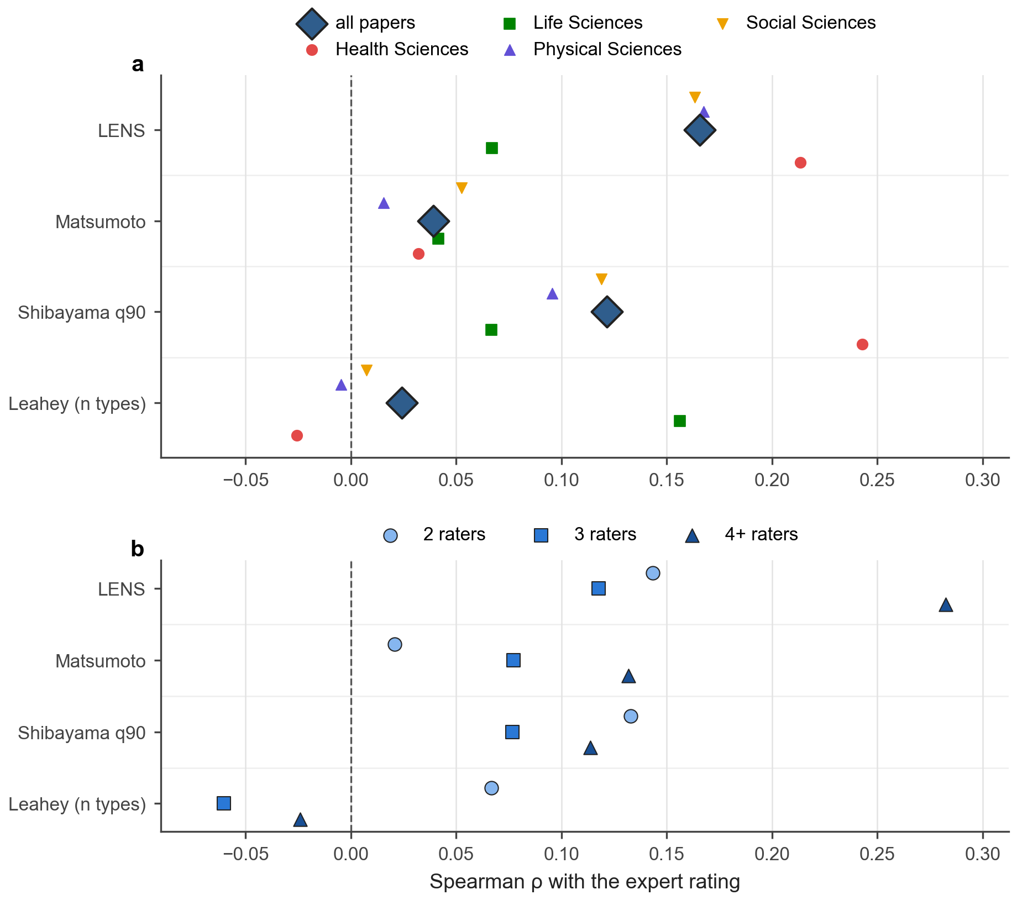
Figure S.4. Spearman correlation of each novelty indicator with the expert rating (a) for all papers (diamonds) and within each OpenAlex domain, and (b) by number of raters per paper (2 raters: 624 papers; 3 raters: 244; 4+ raters: 132).

The indicators are largely unrelated to each other (Figure S.5) with the exception of Matsumoto et al. and Shibayama et al. who correlate positively (0.24 for q90, 0.42 for q100). This is expected, as both measure recombinatorial novelty: the degree to which a paper’s reference list and content from an unusual combination. LENS instead follows a value-oriented definition (Section S.1), and it is practically uncorrelated with Matsumoto et al. and Leahey et al. (0.01 each). With Shibayama et al. (q90), its correlation is even negative (−0.13; −0.29 in the Physical Sciences), although both correlate positively with the expert rating. LENS and the embedding-based indicator therefore capture different aspects of what experts perceive as novel, so their signals complement each other.

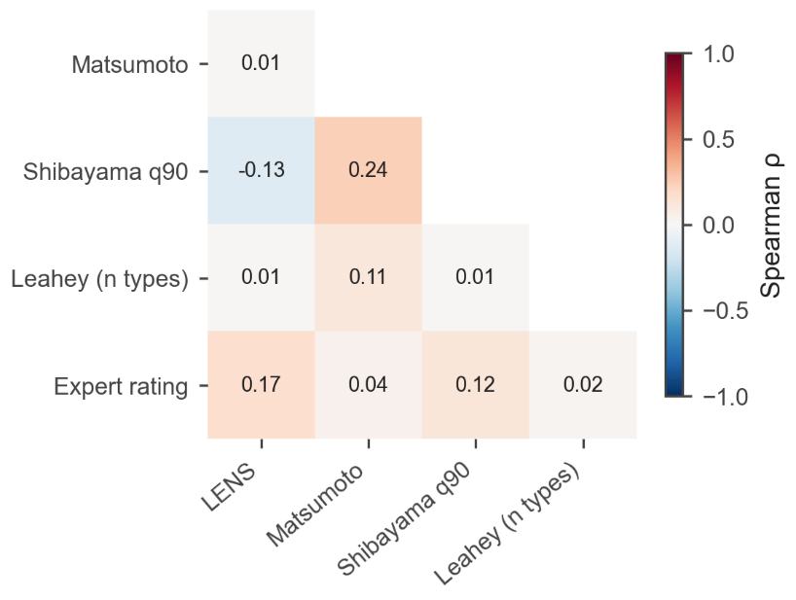
Figure S.5. Spearman correlations between LENS, the benchmark indicators, and the expert rating on the 1,000-paper subset. The matrix is symmetric, so only the lower triangle is shown.

As shown in Figure S.4b, the agreement of LENS with the experts increases with the number of raters per paper. It increases from 0.14 for papers with two raters and 0.12 with three to 0.28 with four or more, which is more than double the correlation of bibliometric (Matsumoto: ρ=0.13) and embedding-based (Shibayama q90: ρ=0.11) approaches. Since a median over more raters averages out individual views, LENS agrees best with a consensus than an individual opinion, which aligns with the hypothesis that LLMs are well suited to approximate the aggregate judgment of an expert panel (Section S.1). None of the not LLM-based benchmark indicators shows a comparable increase.
Future work will explore these synergies. Possible directions are combining LENS with recombination-based indicators, for example by providing the semantic distance of cited works as an additional input or weighting indicators by field.

S.9. Run-to-run Reliability and Comparison of Abstract-only and Full-Text Scores.
LLM inference as commonly deployed is non-deterministic (Atil et al. 2025, Ouyang et al. 2025), especially for recent proprietary reasoning models such as GPT-5, which do not expose sampling temperature as a controllable parameter. It is therefore necessary to test the consistency of an LLM-based indicator across multiple runs. Moreover, because the method can also run on abstracts alone and because full texts are often unavailable (Section S.2), comparing both input conditions is important for assessing the method’s usability.
To assess this without access to the expert ratings, the LENS developers sampled 100 papers from the Challenge dataset. The sample was drawn uniformly over the predicted LENS score distribution, and contains only papers for which both abstract and full text are available under a CC BY license. For each paper, five runs with the abstract and abstract –plus full text were conducted using the same prompt, differing only in the input data (see Figure S.6). Articles with a Full-Text only were not part of this comparison.
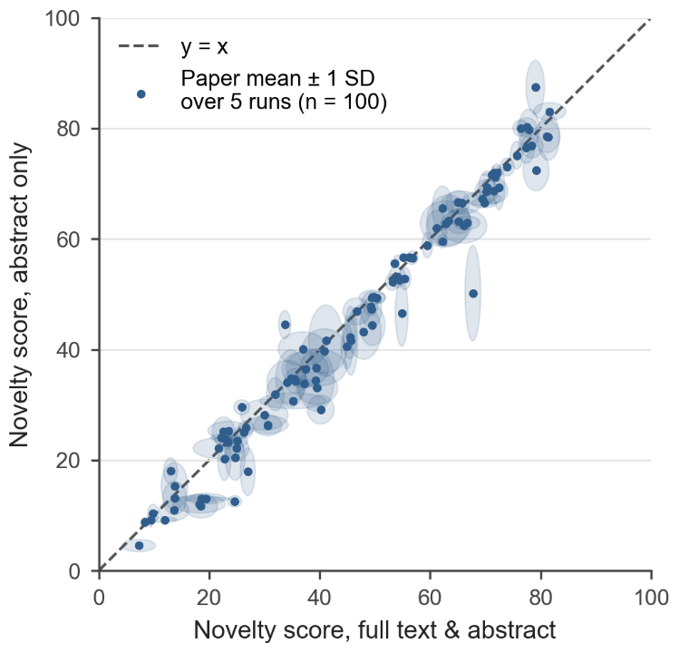
Figure S.6. Mean LENS score per Paper :over Full Text vs Abstract Text Only
Notes. Each point is the mean of five runs for one of 100 papers sampled uniformly over the LENS score range; the x-axis shows scores from full text and abstract, and the y-axis shows scores from the abstract only. Ellipses show ±1 standard deviation across runs in each condition; the dashed line marks identity (y = x). All runs used the model settings described in Table S.1.

Using the full text results in marginally more stable runs. The mean per-paper standard deviation across is 2.22 points for the abstract + full-text runs, and 2.46 points for abstract-only. Both are small compared with the spread of scores across papers in the full dataset (standard deviations of 9.0 and 9.6 points; Table S.4), so the run-to-run variation is minor compared to the differences between papers. The full dataset serves as reference because the uniform sampling of the subset used for this experiment inflates its spread (s.d. of 20.0 points within the sub-sample vs. 9.0 points across the full dataset).
The self-reported uncertainty intervals are also wider for Abstract-only input (mean width 15.2 vs. 13.5 points for full text), which reflects the prompt’s instruction to widen the interval when less information is available (e.g., no full text). Although consistent on average, some outliers remain: The maximum score spread across five runs is 16.7 points with abstract+full text, and 23.1 points with the abstract-only; we plan further investigations to understand any discrepancies.
Comparing the two input conditions, the Abstract+Full Text version scores on average 1.55 points higher than the abstract-only version. A similar effect could also be observed on the full Challenge dataset (0.25 points; see Section S.6). This suggests either that the model discounts the promotional language of abstracts (Vinkers et al. 2015) too strongly, that abstracts can omit information relevant to novelty, or that greater uncertainty leads the model to place its point estimates closer to the lower bound of its interval, even when not explicitly instructed to do so. Although the average difference is small, the two conditions can differ considerably: In the most extreme cases, the Abstract+Full Text score was 17.5 points higher than their abstract-only counterpart (measured for the average of the papers runs). The biggest difference in favor of abstract-only ratings was 10.8; of all 100 papers, four papers differ by more than 10 points between the input conditions, indicating an unusual mismatch between abstract and full text.
Overall, the indicator is stable across runs, and full-text scores are comparable with abstract-only scores, which agrees with other work in this domain (Thelwall 2025). The close alignment between full-text and abstract-only scores may be attributable to peer review and disciplinary publishing norms, which ensures abstracts closely reflect their full texts. For users, this means that LENS can be run on peer-reviewed abstracts alone with comparable results on average, but a single paper’s score may shift by several points depending on the input voume: Where a full text is available, it should be used.

S.10. The Uncertainty Interval
The Challenge asked teams to provide a certainty score of their point estimate. LENS instructs the LLM in the assessment stage to state its own 95% uncertainty interval along with its novelty score (see Section S.3). Verbalized confidence can be better calibrated than token probabilities (Tian et al. 2023), which are not available for proprietary reasoning models. However, LLMs also tend to be overconfident when verbalizing their uncertainty (Xiong et al. 2024).
Figure S.5 compares the width of the LENS interval with the range of expert ratings (highest minus lowest rating) on the 1,000-paper subsample now provided in the Research Artifact. The LENS’ uncertainty intervals are wider when only the abstract is available (mean width 15.4 points) than with the abstract+full Text (13.8 points). Some correlations with expert disagreement would be expected, because the prompt instructs the model to consider divergence when setting the interval. However, LENS does not capture the disagreement between experts. The mean expert range of 36.5 points is about two and a half times the mean LENS width, and the Spearman correlation between the standard deviation of the expert ratings and the LENS interval width is only 0.03. The interval is therefore not a proxy for expert disagreement.
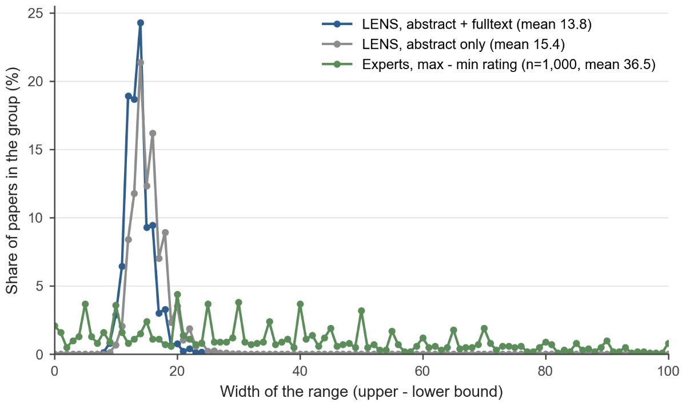
Figure S.5. Width of the LENS 95% uncertainty interval (abstract only and abstract + full text) and range of expert ratings (highest minus lowest rating) per paper on the public 1,000-paper subset.

This is likely because LENS applies a single definition of novelty (see Section S.1) and is, by design, confident within it: Even where it anticipates disagreement, its interval mainly reflects missing or ambiguous information rather than competing interpretations of novelty. Future work will test whether prompting the model with several competing definitions of novelty yields intervals that reflect this disagreement.

S.11. Novelty and Journal Prestige
A positive association between novelty and journal prestige is plausible, because highly ranked journals select contributions that reviewers and editors consider significant and new. At the same time, experts might be biased in their novelty assessment by the publication venue, associating higher-impact journals with greater novelty. Because the experts saw the venue of each paper when rating it, LENS also receives the venue as input, so that both work from the same information. This raises the question of whether LENS measures novelty or merely journal prestige. Figure S.6 plots the mean LENS score per journal against the journal’s 2024 SCImago Journal Rank (SJR; González-Pereira et al. 2010) for the 217 journals with more than 20 papers in the Challenge dataset and an exact SJR match.
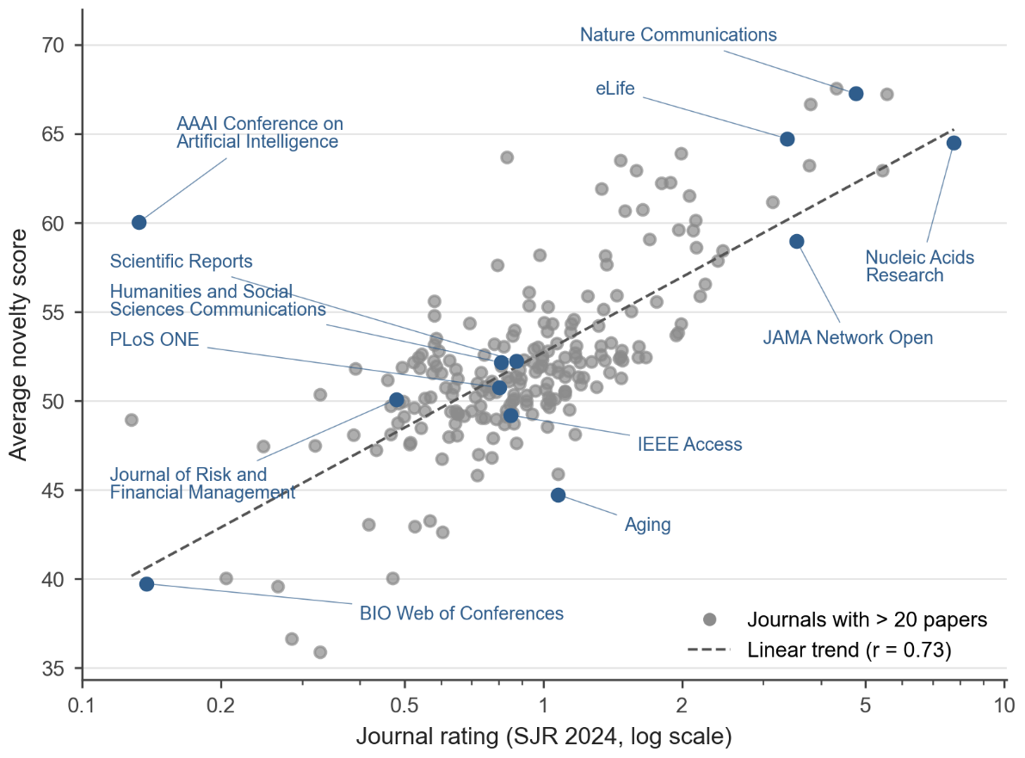
Figure S.6. Mean LENS Score Per Journal vs 2024 SCImago Journal Rank (SJR) 2024
Notes: The figure covers the 217 journals with more than 20 papers in the Challenge data set, based on papers published in 2024. SRJ is shown on a log scale. Selected journals are highlighted and labeled. The dashed line shows the linear trend (r = 0.73).

At the journal level, the average novelty score and SJR are strongly correlated (r = 0.73). There are two possible explanations. LENS might use the venue as a shortcut to prestige, or it may recover from the content the same quality signal that peer review produced when the journals selected these papers. To distinguish the two, an ablation study was conducted, in which the venue information was removed from the input. On the same 100-paper subset as used in Section S.9, the scores for both input conditions differed only by 0.4 points, well below the run-to-run variation of around 2 points. The correlation therefore likely arises from the analysis of the content of the papers rather than from venue-driven status spillovers, suggesting that LENSE captures quality signals similar to those that guide the selection of papers by journals. This makes LENS a candidate tool to support, not replace, editorial screening, once its robustness against gaming has been tested (Section S.12). However, the ablation cannot fully rule out venue effects, because the model may infer the venue from memory (as might human experts).
Journal rank remains an inadequate substitute for a novelty indicator: (1) It captures more than novelty alone; (2) Novelty varies considerably across papers within the same journal; (3) Journal metrics cannot be applied to unpublished work (whereas a novelty indicator can); and (4) They carry the limitations of citation-based metrics (as discussed in the Manuscript). LENS also works in contexts which have not yet enacted selection, such as preprints or submitted manuscripts; these opportunities are discussed in the Manuscript.
It has to be mentioned that this result appears to be in contrast with Wang et al. (2017), who found novel publications in journals with low Impact Factors. However, they also use a different definition of novelty, and their indicator is based on reference combinations rather than on content.

S.12 Limitations and Future Research
LENS sets a new benchmark in the automated assessment of novelty within text-based outputs (Section S.7). However, there are a few aspects that should be addressed in future work. First, LENS ranks papers more accurately than it places them on the continuous scale (Section S.7) – it orders papers by novelty more reliably than it predicts the exact score an expert would give – and its absolute scale was never calibrated against expert ratings (Section S.5).
Second, the weights and architecture of GPT-5 are unknown, its reasoning tokens are hidden, the sampling temperature (which controls the randomness of the output) cannot be set, and model snapshots may be retired without notice.
Third, design Hypothesis 3 (Section S.1) relies on knowledge the model acquired in training. For papers published before the model’s knowledge cutoff (September 30, 2024, for the GPT-5; OpenAI 2025a) the model might know how the work was received later, which risks the hindsight bias that hypothesis 2 aims to avoid. For papers published after the cutoff, it lacks the most recent state of the field. The Challenge dataset, with papers published from 2023 to 2025, spans both periods. Nevertheless, the expert raters might have also been subject to hindsight bias during the Challenge.
Fourth, the prompt was developed on a small, non-representative set of papers (Section S.5), and the calibration anchors were chosen by subjective judgment and concentrated at the top of the scale (Section S.3). Both might introduce field-specific biases; future work will document a systematic selection of calibration examples.
Fifth, full texts were available for 59.4% of the papers. Open-access practices differ between fields and publishers, so input quality is not distributed evenly across fields.
Sixth, the binary classification threshold of 60 is a heuristic choice; their sensitivity will be tested in future work.
Seventh, the interval is the models self-reported uncertainty, reflecting the model’s estimation rather than disagreement between experts, and it has not yet been validated (Section S.10); future work will calibrate those intervals.
Lastly, the present post hoc analyses use either the LENS outputs or the now-public 1,000-paper subset (Section S.13); additional analyses with the full expert dataset are planned.
Beyond the points mentioned above, follow-up work will examine: (1) fairness across fields, article types and author groups, including the differences in score distributions between fields (particularly STEM vs. Social Sciences and Humanities); (2) Gameability (Gibney 2025, Goodhart 1984, Strathern 1997), that is, how far scores can be raised by rewriting, by adopting the vocabulary of the evaluation criteria, or by injecting hidden instructions into full texts; (3) Systematic ablations of inputs, prompt components, calibration anchors, model size, and reasoning effort, to determine which components drive the performance of LENS; (4) Open-weight models to improve reproducibility and reduce cost; and (5) Ways to represent disagreement between interpretations of novelty rather than a single consensus score.

Exhibit S.1. – Example Output.
The following shows an example output of the LENS pipeline for the article: Matutini E, Chiara G, Brondi S (2025). Agency and Advocacy in Social Work: Promoting Social and Environmental Justice Through Professional Practice. Sustainability, 17(20): 9208.
LENS score 54.6 (95% interval 46–60)
field_and_context: Field: Social work (eco-social/green social work), environmental justice (EJ), epistemic justice. 2025 bottleneck: how frontline social workers operationalize EJ amid climate/pollution burdens on vulnerable groups; weak integration of community knowledge into institutional decision-making; lack of codified environmental competencies in social-work mandates/curricula; limited practice models for building territorial alliances across social, health, environmental, and civic actors. Prior art: EJ triad (distribution, recognition, procedure) widely used but criticized for limited engagement with knowledge hierarchies and relational/place-based dynamics; green/eco-social work calls since 2010s; growing discourse on epistemic justice in social work and STS, but sparse practice-oriented, empirically grounded frameworks uniting EJ + epistemic justice for day-to-day social work in European contexts.
novelty_case: Integrative/conceptual: proposes an eco-epistemic perspective explicitly fusing EJ with epistemic justice for social-work practice (centers agency/advocacy as mediational, relational, place-attuned). Practice framework: three practitioner profiles (Detached; Sensitive/Conscious; Expert) tied to competencies and organizational enablers; specifies training pathways, cross-sector alliance-building, and governance/regulatory levers to legitimize EJ work in services. Empirical: two-phase qualitative program (narrative interviews + participatory training/research with regional professional body in Italy) grounding the framework in practitioner narratives; cross-phase synthesis to derive operational recommendations. Value: gives practitioners/managers an actionable lens to elevate local knowledge, counter epistemic exclusion in environmental decisions, and structure territorial alliances – addressing a persistent implementation gap in eco-social work.
skeptical_counter: Conceptual overlap: recognition justice in EJ already entails epistemic dimensions; social work literature since 2010s has advanced green/eco-social practice and has engaged epistemic justice – ‘eco-epistemic’ may be rebranding more than reframing. Empirical limits: small, region-specific samples; training program participants linked to professional association → selection/advocacy bias; no outcome evaluation of proposed pathways; typology may mirror existing competency/readiness stage models. External validity uncertain beyond Italian governance context. Limited methodological novelty (standard interviews, thematic analysis, participatory workshop).
interval_reasoning: Uncertainty from incomplete full text; difficulty pinning exact precedence of ‘eco-epistemic’ framing in social work vs. EJ/STS; interdisciplinary interpretation variance (social work vs. EJ scholars). Empirical scope localized and modest. Still, contribution plausibly incremental-to-moderate in practice guidance.
resolution: Net contribution = solid integrative/practice-oriented synthesis with localized empirical grounding. Adds clarity and operational steps for embedding EJ in social-work practice via an epistemic justice lens; addresses a real implementation gap but does not break new theoretical ground relative to green/eco-social work and recognition/epistemic justice literatures. Limited sample and absent outcomes cap impact. Field better off with this paper (clearer framing + typology + governance levers), but shift is incremental rather than field-shaping.

HEADER

S.13. Benchmark Novelty Indicators, Implementation and Verification
To compare LENS with established approaches, three bibliometric novelty indicators from different families were computed for the 1,000-paper subset: a citation-based indicator (Matsumoto et al. 2021), an indicator that combines citations with text similarity (Shibayama et al. 2021), and a purely text-based indicator (Leahey et al. 2023). All three use OpenAlex data retrieved on October 24–28, 2026; every paper in the subset has an OpenAlex record, an Abstract, and at least one reference. Because the indicators use different scales (see Figure S.7), they are compared by their ranking of papers rather than by absolute scores. The code for all three indicators is part of the Research Artifact. The following paragraphs describe each indicator, the adaptations it required, and how these were verified.
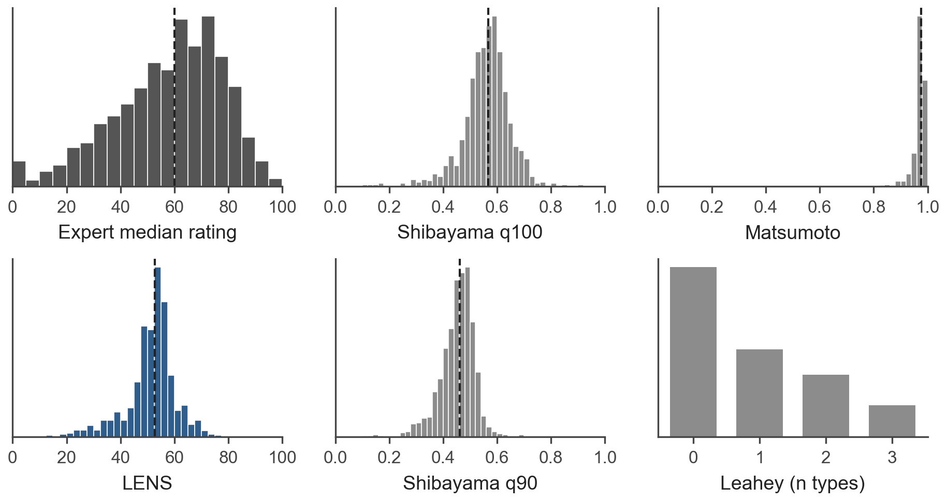
Figure S.7. Score distribution of all bibliometric indicators together with LENS and Expert median rating score distribution on the published 1000-paper subset
Matsumoto et al. (2021) consider a paper novel if its references are rarely cited together in its field. Building on the overlap measure of Dahlin and Behrens (2005), they compare the reference list of a focal paper i with that of each same-field paper j, that is, each earlier paper in the same field that cites at least one of i’s references. The overlap of a pair is the Jaccard index, OSᵢⱼ = |Refᵢ ∩ Refⱼ| / |Refᵢ ∪ Refⱼ|, which ranges from 0 (no shared references) to 1 (identical reference lists). Novelty is one minus the mean overlap across all n same-field papers: Novelty(i) = 1 − (1/n) Σⱼ OSᵢⱼ. Only references published within the ten years and same-field papers published within the three years before the focal paper are considered.
Three adaptations were necessary.
First, OpenAlex replaces Web of Science as the data source, and the OpenAlex primary subfield (252 subfields) replaces the Web of Science subject categories (254) at a similar granularity. Second, to limit API costs, at most 1,000 same-field papers were sampled at random per focal paper; repeated sampling left the ranking practically unchanged (Spearman correlation between rankings > 0.9999). Third, non-research items such as editorials and errata were excluded. The indicator could not be computed for 26 papers that had either no references within the ten-year window or no same-field papers citing their references. Because Matsumoto et al. (2021) share neither code nor paper-level scores, the implementation could not be verified directly against their results.

Shibayama et al. (2021) consider a paper novel if it cites references that are semantically distant from each other. They represent each reference by the mean word embedding of its title (the authors also test abstracts and keywords), using the 200-dimensional scispaCy vectors trained on biomedical text (Neumann et al. 2019), and compute the cosine distance between all N(N−1)/2 reference pairs. Novelty is the q-th percentile of these distances; the authors report that q = 100, the single most distant pair, performs best on their data.
Because the scispaCy vectors cover biomedical text only, the present implementation uses the embedding model Qwen3-Embedding-8B (Zhang et al. 2025), deployed on the authors infrastructure, instead. To check this substitution independently of the expert ratings, the embedding similarity of reference pairs was correlated with their bibliographic coupling (the share of references they have in common). The Pearson correlation is 0.40 for Qwen and 0.14 for scispaCy across all 45,691 pairs, and 0.41 versus 0.17 for the 170 Health Sciences papers, where scispaCy should perform best. On the 1,000-paper subset, the indicator also correlates more strongly with the expert median when based on Qwen (ρ = 0.12) than on scispaCy (ρ = 0.04).
Two settings are reported: q = 100, as recommended by the authors, and q = 90. The q = 100 version correlates strongly with the number of references (ρ = 0.50), because more references yield more pairs and thus a more extreme maximum, whereas q = 90 hardly does (ρ = 0.10) and correlates equally well with the expert median (ρ = 0.12). A variant based on abstracts instead of titles correlates less with the expert median (ρ = 0.09) and was not pursued further.
To validate the percentile computation, the published pairwise distances for the references of 946 anonymized articles were used to reproduce the six percentiles reported by the authors. All six were reproduced exactly with a non-interpolating percentile definition. The authors’ published code interpolates percentiles linearly and reproduces only q = 100 and q = 50; the present implementation therefore follows the definition given in the paper.

Leahey et al. (2023) measure novelty solely from how authors describe their own work. The method was developed for retrospective essays by the authors of 2,540 highly cited “Citation Classics” and is therefore not validated for recently-published articles; nevertheless, it is included as a purely text-based reference point. A sentence is tagged when it contains a “new” term (e.g., “novel,” “propose”) together with a term of a given type (result, theory, or method). This implementation uses the published dictionary and the four disambiguation rules from the authors’ appendix. The novelty score is the number of novelty types found in the title and abstract and ranges from 0 to 3.

The indicator of Arts et al. (2025), which relies on new words, phrases, and word combinations in titles and abstracts that are later reused, was also considered. However, its published scores are based on a fixed OpenAlex snapshot of January 9, 2024, which covers only 67 papers of the subset, and recomputing them would require the text of the entire prior literature. The indicator was therefore not included.

S.14. Stimulus Corpus Creation
A total of 106,788 publications were extracted from OpenAlex; we deliberately oversampled such that, after cleaning, the stimulus papers corpus would number 100,000. The publications selected were the published versions of Open Access (gold, diamond or hybrid) articles, published from over a 24 month window from .2023 to the date of collection in December 2025. In order to eliminate short texts that are not true publications, we required all items to include a DOI, an abstract, at least one named author, and at least one cited reference. Review articles were allowed, as known non-novel publications (to avoid sampling on the dependent variable). However, paratexts and retracted articles were excluded, as were articles not written in the English language. At the time of corpus-building, OpenAlex had many false positives regarding English language status within its metadata, particularly with publications in Bahasa Indonesia and Russian, so additional post-processing steps were used to eliminate as many of these as possible – including use of the langdetect Python package and detection of stated language from the HTML tags of journal websites. Post-processing also removed publications associated with this submission’s authors; publications associated with metascience-related journals in which this submission’s authors commonly publish, such as Management Science, Scientometrics, or Research Policy; journals added to and later removed from the OpenAlex database (at the time represented in the database as “Deleted Journal”); and publications containing a number of keywords in their title associated with not being primary research in their titles, such as "editorial".

S.15. Survey Design
The survey itself was designed to pick up on a linear range of conventional novelty, and included items relating to research questions not covered within this publication. Screenshots of the main phase of the survey follow:
The design of the survey focused on quantifying novelty within a linear range of 0 (indicated by a checkbox saying “Not Novel” to 100), allowing discernment of conventional and incremental novelty at the cost of reduced ability to discern differing degrees of radical novelty. The interface for submitting this score was a slider, and scores could not be submitted until all sliders had been interacted with. A binary question on whether the publication was novel was also included.
Further investigation into novelty is provided by ratings of particular subtypes of novelty – novelty in theory, methods, data, findings, context and overall contribution. As these subtypes may not be relevant for every publication, for instance a piece of literary criticism would not have data, raters were allowed to mark these as “Not Applicable”.
In addition to novelty the survey asked questions on originality, expected to correlate with novelty, and similarity, as novelty is often conceptualised in computer science contexts as the additive complement of similarity.
Finally respondents were asked to self-rate their expertise at assessing the publication they had been provided.

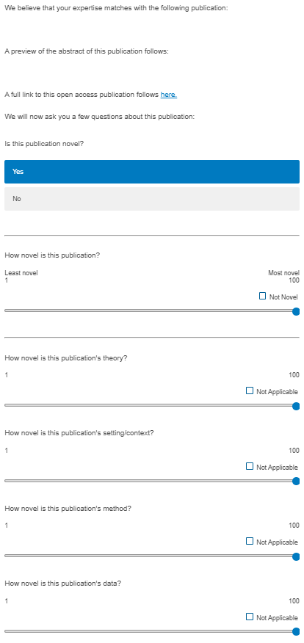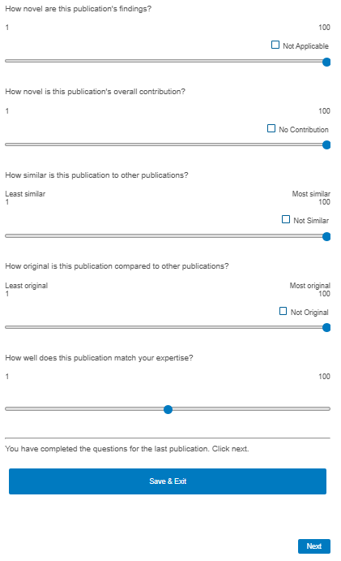
Screenshot S1 – the survey itself, pictured in the main phase.
Respondents received individualized publications to rate, with the Title and a preview of the Abstract (necessitated due to character limits in Qualtrics), as well as a link to the article’s Full Text, for which click-throughs were tracked. Participants were invited to consider the questions outlined earlier in this section and individual respondents could receive up to five publications, with each completed rating recorded.
After the survey was completed some cleaning steps were implemented, removing: (1) The records of those who rejected the terms and conditions of the survey were removed; (2) Any incomplete ratings; (3) Any rankings in which both self-recorded expertise was set at 1 and all novelty scores were fixed at 0 (which represented “decline to rate”); and (4) Any ratings from individuals who had emailed us post facto to request that we remove their data.
Raters​ | Papers​
0​ | 69227​
1​ | 21009​
2​ | 10632​
3​ | 3917​
4​ | 1270​
5​ | 417​
6​ | 159​
7​ | 42​
8​ | 21​
9​ | 7​
10​ | 4​
11​ | 2​

Table S.7. Number of respondents who rated each publication
After these cleaning steps 37480 publications received valid ratings by at least one respondent. The modal and median number of ratings provided per reviewer was one; 1.6% of respondents evaluated the maximum number of papers (5).
Raters used the whole range of expertise ratings but overall the raters considered themselves somewhat expert on the publications they were provided – with a median expertise of 80 (mean of 75) (Figure S.7). No substantial or significant differences in scores were present between raters with high and low self-assessed expertise. 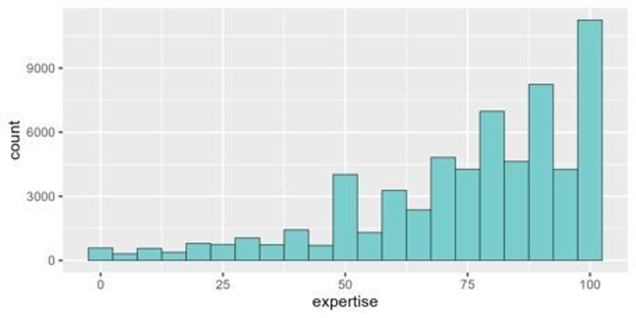
Figure S.8. Self-rated expertise of human raters who answered the survey
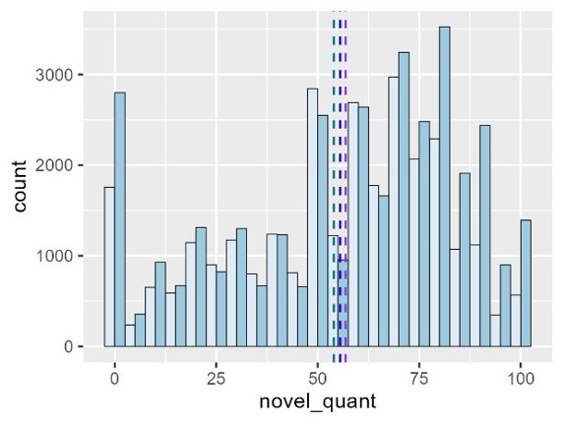
Figure S.9. A comparison of scores provided by respondents whose expertise was below (light blue) or above/at (dark blue) the median. The light blue dotted bar indicates the mean of the first group, the dark blue bar the mean of all raters, and the purple bar the mean of the latter group.
Novelty scores and originality scores showed a correlation as expected, although not the case for every individual rating, broadly our respondents appeared to conceptualise these two concepts as linked. However, in contrast, the expected inverse correlation between similarity and novelty did not appear, indicating that the framing of novelty as the additive complement of similairty is not consistently held among respondents.

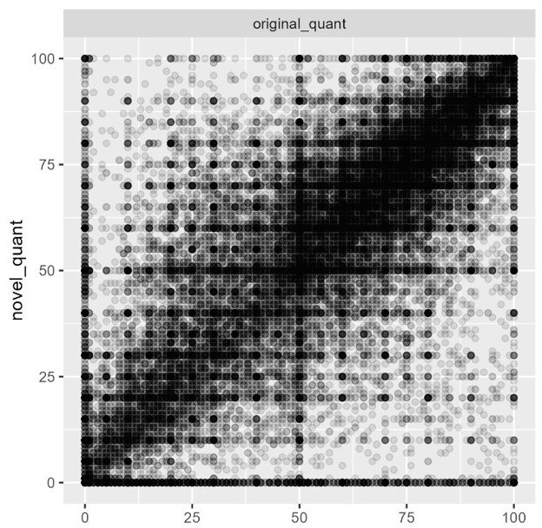
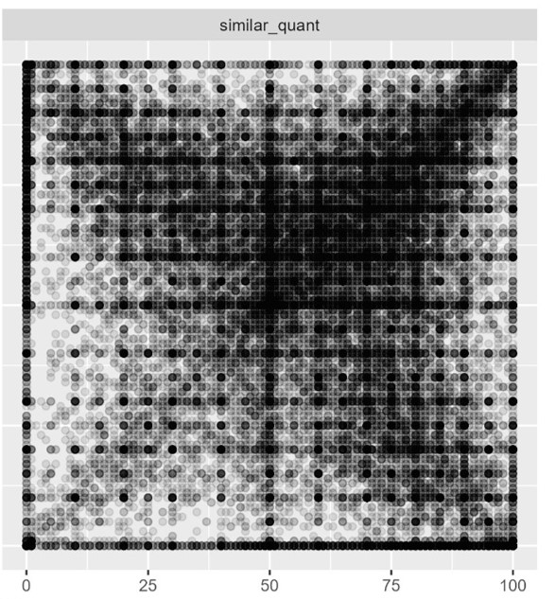
Figure S.10. Novelty scores plotted against corresponding originality and similarity scores.
It was also noted that all six subtypes of novelty considered within the survey showed some positive correlation with overall novelty.
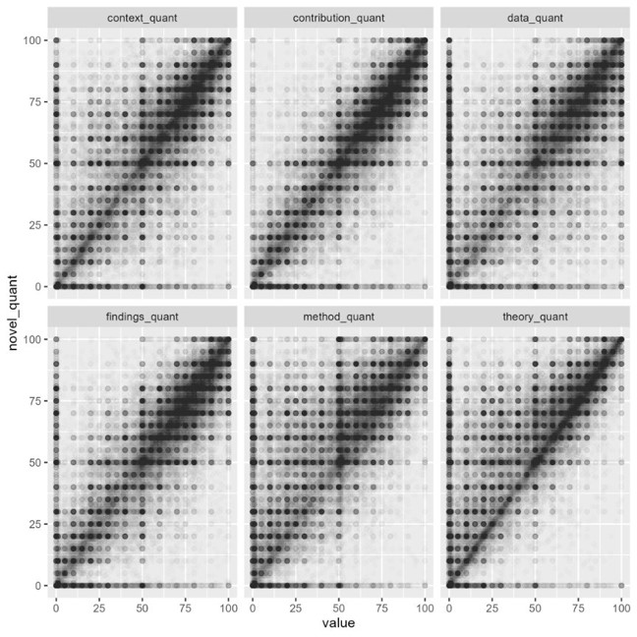
Figure S.11. Novelty scores plotted against scores for subcategories of novelty (context, contribution, data, findings, method and theory)

S.16. Competition Evaluation
Continuous-score evaluation assessed how closely algorithmic novelty scores corresponded to human assessments using median absolute error (MedAE), Spearman's rank correlation, and Kendall's tau. This is particularly relevant when the magnitude of novelty matters, rather than simply whether one paper is more novel than another. Ranking evaluation examined how well algorithms reproduced the ordering of papers based on human judgments, using median rank displacement (MedRD), Kendall's tau, linear weighted kappa (LWK), and quadratic weighted kappa (QWK). This perspective is especially relevant for prioritization tasks, such as identifying the most novel papers or selecting promising research proposals. Finally, LOOC, examined the robustness of evaluations by assessing whether the field-level consensus remained stable when individual contributions were omitted.

References
Arts S, Melluso N, Veugelers R (2025) Beyond citations: Measuring novel scientific ideas and their impact in publication text. Rev. Econom. Statist., ePub ahead of print.
Atıl B, Aykent S, Chittams A, Fu L, Passonneau RJ, Radcliffe E, Rajagopal GR, Sloan A, Tudrej T, Ture F, Wu Z, Xu L, Baldwin B (2025) Non-determinism of “deterministic” LLM system settings in hosted environments. Proc. 5th Workshop Evaluation Comparison NLP Systems (Eval4NLP 2025) (Association for Computational Linguistics, Mumbai, India).
Azzalini A (1985) A class of distributions which includes the normal ones. Scand. J. Statist. 12(2):171–178.
Boudreau KJ, Guinan EC, Lakhani KR, Riedl C (2016) Looking across and looking beyond the knowledge frontier: Intellectual distance, novelty, and resource allocation in science. Management Sci. 62(10):2765–2783.
Brown TB, Mann B, Ryder N, Subbiah M, Kaplan J, Dhariwal P, Neelakantan A, Shyam P, Sastry G, Askell A, Agarwal S, Herbert-Voss A, Krueger G, Henighan T, Child R, Ramesh A, Ziegler DM, Wu J, Winter C, Hesse C, Chen M, Sigler E, Litwin M, Gray S, Chess B, Clark J, Berner C, McCandlish S, Radford A, Sutskever I, Amodei D (2020) Language models are few-shot learners. Adv. Neural Inform. Processing Systems 33:1877–1901.
Bruine de Bruin, W., Carman, K.G. (2018), Measuring Subjective Probabilities: The Effect of Response Mode on the Use of Focal Responses, Validity, and Respondents’ Evaluations. Risk Analysis, 38: 2128-2143.
Cohen J (1968) Weighted kappa: Nominal scale agreement with provision for scaled disagreement or partial credit. Psych. Bull. 70(4):213–220.
Dahlin KB, Behrens DM (2005) When is an invention really radical? Defining and measuring technological radicalness. Res. Policy 34(5):717–737.
Dubois Y, Galambosi B, Liang P, Hashimoto TB (2024) Length-controlled AlpacaEval: A simple way to debias automatic evaluators. Proc. 1st Conf. Language Modeling (COLM 2024) (Philadelphia), https://arxiv.org/abs/2404.04475.
Fischhoff B (1975) Hindsight ≠ foresight: The effect of outcome knowledge on judgment under uncertainty. J. Experiment. Psych. Human Perception Performance 1(3):288–299.
Gibney E (2025) Scientists hide messages in papers to game AI peer review. Nature 643(8073):887–888.
González-Pereira B, Guerrero-Bote VP, Moya-Anegón F (2010) A new approach to the metric of journals’ scientific prestige: The SJR indicator. J. Informetrics 4(3):379–391.
Goodhart CAE (1984) Problems of monetary management: The U.K. experience. Monetary Theory and Practice: The U.K. Experience (Macmillan, London), 91–121.
Leahey E, Lee J, Funk RJ (2023) What types of novelty are most disruptive? Amer. Sociol. Rev. 88(3):562–597.
Liang W, Zhang Y, Cao H, Wang B, Ding DY, Yang X, Vodrahalli K, He S, Smith DS, Yin Y, McFarland DA, Zou J (2024) Can large language models provide useful feedback on research papers? A large-scale empirical analysis. NEJM AI 1(8):AIoa2400196.
Lord CG, Lepper MR, Preston E (1984) Considering the opposite: A corrective strategy for social judgment. J. Personality Soc. Psych. 47(6):1231–1243.
Matsumoto K, Shibayama S, Kang B, Igami M (2021) Introducing a novelty indicator for scientific research: Validating the knowledge-based combinatorial approach. Scientometrics 126(8):6891–6915, https://doi.org/10.1007/s11192-021-04049-z.
Merton, R. K. (1968) The Matthew Effect in Science. Science, 159(3810), 56–63.
Nelder JA, Mead R (1965) A simplex method for function minimization. Comput. J. 7(4):308–313.
Neumann M, King D, Beltagy I, Ammar W (2019) ScispaCy: Fast and robust models for biomedical natural language processing. Proc. 18th BioNLP Workshop Shared Task (Association for Computational Linguistics, Florence, Italy), 319–327.
OpenAI (2025a) GPT-5 model documentation. Accessed October 26, 2026, https://platform.openai.com/docs/models/gpt-5.
OpenAI (2025b) GPT-5 nano model documentation. Accessed October 26, 2026, https://platform.openai.com/docs/models/gpt-5-nano.
OpenAI (2025c) GPT-5 system card. Report, OpenAI, San Francisco. Accessed October 26, 2026, https://openai.com/index/gpt-5-system-card/.
Ouyang S, Zhang JM, Harman M, Wang M (2025) An empirical study of the non-determinism of ChatGPT in code generation. ACM Trans. Software Engrg. Methodology 34(2):Article 42, 1–28.
Panickssery A, Bowman SR, Feng S (2024) LLM evaluators recognize and favor their own generations. Adv. Neural Inform. Processing Systems 37 (Curran Associates, Red Hook, NY).
Pier EL, Brauer M, Filut A, Kaatz A, Raclaw J, Nathan MJ, Ford CE, Carnes M (2018) Low agreement among reviewers evaluating the same NIH grant applications. Proc. Natl. Acad. Sci. USA 115(12):2952–2957.
Priem J, Piwowar H, Orr R (2022) OpenAlex: A fully-open index of scholarly works, authors, venues, institutions, and concepts. Preprint.
Runco MA, Jaeger GJ (2012) The standard definition of creativity. Creativity Res. J. 24(1):92–96.
Shibayama S, Yin D, Matsumoto K (2021) Measuring novelty in science with word embedding. PLoS One 16(7):e0254034.
Strathern M (1997) “Improving ratings”: Audit in the British university system. Eur. Rev. 5(3):305–321, https://doi.org/10.1002/(SICI)1234-981X(199707)5:3<305::AID-EURO184>3.0.CO;2-4.
Thelwall M (2025) Evaluating research quality with large language models: An analysis of ChatGPT’s effectiveness with different settings and inputs. J. Data Inform. Sci. 10(1):1–25.
Tian K, Mitchell E, Zhou A, Sharma A, Rafailov R, Yao H, Finn C, Manning CD (2023) Just ask for calibration: Strategies for eliciting calibrated confidence scores from language models fine-tuned with human feedback. Proc. 2023 Conf. Empirical Methods Natural Language Processing (EMNLP 2023) (Association for Computational Linguistics, Singapore), 5433–5442.
Uzzi B, Mukherjee S, Stringer M, Jones B (2013) Atypical combinations and scientific impact. Science 342(6157):468–472.
Vinkers CH, Tijdink JK, Otte WM (2015) Use of positive and negative words in scientific PubMed abstracts between 1974 and 2014: Retrospective analysis. BMJ 351:h6467.
Wang J, Veugelers R, Stephan P (2017) Bias against novelty in science: A cautionary tale for users of bibliometric indicators. Res. Policy 46(8):1416–1436,.
Wei J, Wang X, Schuurmans D, Bosma M, Ichter B, Xia F, Chi E, Le QV, Zhou D (2022) Chain-of-thought prompting elicits reasoning in large language models. Adv. Neural Inform. Processing Systems 35:24824–24837.
Wuestman M, Hoekman J, Frenken K (2020) A typology of scientific breakthroughs. Quantitative Science Studies, 1(3), 1203–1222.
Xiong M, Hu Z, Lu X, Li Y, Fu J, He J, Hooi B (2024) Can LLMs express their uncertainty? An empirical evaluation of confidence elicitation in LLMs. Proc. 12th Internat. Conf. Learn. Representations (ICLR 2024) (OpenReview.net, Vienna), https://arxiv.org/abs/2306.13063.
Zhang Y, Li M, Long D, Zhang X, Lin H, Yang B, Xie P, Yang A, Liu D, Lin J, Huang F, Zhou J (2025) Qwen3 Embedding: Advancing text embedding and reranking through foundation models. Preprint.
Zheng L, Chiang W-L, Sheng Y, Zhuang S, Wu Z, Zhuang Y, Lin Z, Li Z, Li D, Xing EP, Zhang H, Gonzalez JE, Stoica I (2023) Judging LLM-as-a-judge with MT-Bench and Chatbot Arena. Adv. Neural Inform. Processing Systems 36 (Datasets and Benchmarks Track):46595–46623.

n.b. This sometimes causes discrepancy between the total reported in the Manuscript, the Technical Supplement, and the Research Artifact. We will reconcile these during the development process.
Including what Wuestman et al. (2020) termed “scientific breakthroughs”, which are "discoveries that transform the knowledge frontier and have a major impact on science, technology, and society".
Resulting from a combination of heuristics, including “number heaping” aka “digit preference” (e.g., Bruine de Bruin & Carman, 2018).
The (un-)certainty interval was not part of the Challenge evaluation calculations.
In practice a small minority of publications fall outside this window but within the year 2023 as: i) collection of publications took place over the course of weeks, so the window moved, and: ii) complexities arising from multiple types of bibliometric metadata on date. The API call to fetch the publications searched by published date. This data is provided by publishers and its fidelity varies wildly, with the 1st of January used as a placeholder where exact dates are unavailable. The rolling 24-month window was imposed in post-processing on the basis of created date, indicating entry into the OpenAlex database. This allows both for publications that erroneously appear outside the window and for publications that were indexed late to fall outside the desired window. Neither case is frequent.
Very rarely a rater was able to submit a second rating for the same publication due to a software error. Duplicates were removed, favouring any ratings win which the rater clicked through to the full text of the publication, or the older submission if this was not available as a method of discrimination.

